Activity 3 Putting It All Together

Existing code in the form of libraries is incredibly useful and a powerful aspect of object-oriented programming. Beyond the standard Java library, users around the world have created and published libraries to perform countless tasks. One such library, which you will be using in this activity and the one that follows, is the Sinbad library. This library allows you to create a Java program that can connect to a data source, read in data, and then process this data. The goal of this activity is to provide practice working with the Sinbad library. Before beginning, ensure that you have set up your IDE appropriately based on instructions from your teacher.

1. Run the main method in the Welcome01 class and provide the location and temperature that are printed.

|  |
| --- |

1. Go to the following link, <https://w1.weather.gov/xml/current_obs/>, and find the four-character code for an additional location. To find the code, you first must select the state or territory from the drop-down box shown here.

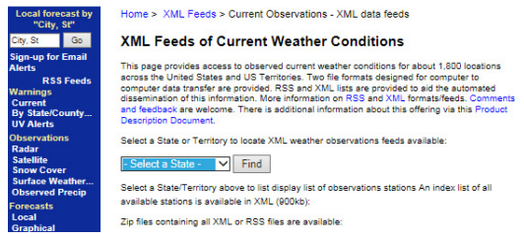

From the resulting list, choose a four-character code and modify the main method in Welcome01 to pull information from this location instead. Provide the four-character code here.

|  |
| --- |

Then write what is displayed when running your main method with this new code.

|  |
| --- |

Share your results with a partner

Once you have verified that the Sinbad library is installed correctly, you will work through the “Fetching Objects” tutorial found at <https://github.com/berry-cs/sinbad/blob/master/tutorials/java/welcome02-obj.md>.

1. Using the location from the previous question, modify Welcome02_Object.java that you completed in the tutorial to create a third Observation object for your identified location, and then write the code to determine the coldest location between all three Observation objects.

Next, you will work through the “Arrays and Lists of Objects” tutorial found at

<https://github.com/berry-cs/sinbad/blob/master/tutorials/java/welcome03-objs.md>.

1. How many weather station objects are in your state?

|  |
| --- |

1. What is another way you could filter weather stations?

|  |
| --- |

1. Modify WeatherStation.java and Welcome03_List to filter based on latitude, showing the weather station that is furthest south. Do not remove existing code that sorts weather stations based on state. What is the southernmost weather station you found?

|  |
| --- |

With a partner, answer and discuss the following questions

1. What is an additional question that can be answered about weather stations or observations based on the code that you wrote?

|  |
| --- |

1. How much additional code would it take to answer this question?

|  |
| --- |